Digi PA for Youth CF – Feasibility
Children’s Health and Exercise Research Centre, Sport and Health Sciences, College of Life and Environmental Sciences, St Luke’s Campus, University of Exeter, Exeter, UK, EX1 2LU.

Principal Investigator: Dr Samantha van Beurden
Telephone: 01392 726440
Email: s.b.vanbeurden@exeter.ac.uk

Participant Information Sheet (12-15 year olds)

Study title
Feasibility randomised controlled trial of digital physical activity promotion materials for young people with cystic fibrosis (Digi PA for Youth CF – Feasibility).

Study Invitation
Thank you for reading this information sheet! We are looking for young people between 12 and 18 years old who are living with cystic fibrosis and can use the internet with, for example, a smartphone, tablet, or laptop. This is why you were given this information sheet. We would very much like you to take part in our research study. Full details about this research study are included below. It should only take you about 10 minutes to read. Please talk to your parents or a guardian about this information too.

What is this study about?
This study is being run to see if physical activity promotion material is seen to be easy to understand and captures the attention of young people living with cystic fibrosis. This material will be delivered digitally and can be seen online. In the future, we would like to run a much bigger study to see whether the different digital materials about physical activity are the same or whether one is better than the other in trying to help young people with CF be more active. So, in this research study we are running now, we also want to find out if people like you:
- want to take part in studies like this.
- are happy to complete the questionnaires.
- are okay with wearing an activity monitor on the wrist.
- Are happy taking part in two interviews during the research study period.

Why are we doing this study?
Being active can help you to stay healthy. There are also other benefits, like feeling better in yourself or having a better mood and getting to spend time with other people. So, we would really like to know if what young people think about some of the digital physical promotion material that is meant to help and prompt them to be more active, and if we can run a bigger study with the same questions and tasks in future.

Why am I being asked to take part?
We are inviting all young people between 12 and 18 years old with cystic fibrosis to take part in this study. It doesn’t matter physically active you are – you just need something that allows you to use the use the internet. Like a smartphone, tablet, or laptop.

What would taking part involve?
If you are happy to take part, we will first ask you and your parents or guardians to sign forms to confirm that you want to take part in this study and that they agree with this too. After this you will be asked to complete several different tasks. When these tasks are completed, you will be going into one of two groups. Group selection is done by chance – like flipping a coin. Each group will receive physical activity materials, but they are different.
The tasks we would like you to do are:
- complete questionnaires (3 times during the study).
- wearing an activity watch for 7 days and writing a few notes about the activities you’ve done during those 7 days (3 times during the study).
- use the digital physical activity promotion materials (as often as you like).
We may also ask you have a chat via telephone or computer software (e.g., Zoom) with the researcher. In these chats the researcher will ask you some questions about the physical activity promotion materials and what you think about the research study. The study will last for a total of six months (24 weeks). You will be asked to complete the tasks the start of the study (baseline), then again after one month, and for one final time at the end of the 6-months. Details of the specific tasks are detailed in the figure below:

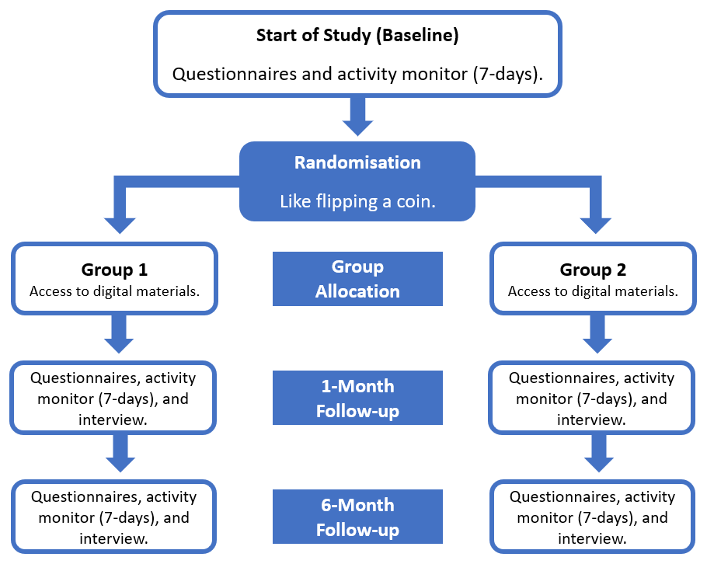

During the 6-month study period, you and your parents/carers will be required not to share details of the digital physical activity promotion material received with other people. This is to make sure that the results are as useful as possible.

Is this study safe?
Everything we are asking you to do is safe. The only thing that will be different to your usual routine is the use of the online advice about physical activity. The activity monitor goes on your wrist like a watch, so it might be a bit itchy if you don’t normally wear a watch, but this should disappear quickly. The questionnaires and interviews are safe too. When you are completing these tasks, it is important to know that if you don’t want to answer a question, then you don’t have to. You can also ask the researcher for help if needed. Your normal medical care will not change if you take part in this study. Please note that your access to the digital physical activity resources will be stopped once the study has ended.
This project has been reviewed by a group of experts called an Ethics Committee. This group makes sure that everything we ask you to do is safe. The specific group that has looked at this project is called the West Midlands – Solihull Research Ethics Committee.

Do I have to take part?
No. It really is completely up to you. If you do decide to take part:
- You will need to sign a form to say that you are happy to take part.
- Your Mum, Dad, or a guardian will need also to sign a form to say that they are happy for you to take part.
- You will be given a copy of both forms to keep.
- You will still be free to stop taking part. This can happen at any time, and you don’t have to tell us why. But, if you are happy to let us know why, this will help us a lot when we do the bigger study in future.

Do I get paid to take part?
People who take part in research are usually volunteers - they do not get paid. But, to thank you for taking part we will give £10 gift vouchers when the tasks are completed at a particular time point. This Because we have tasks at 3 time points, this means you can receive a total of £30 if to thank you.

What should you do if you want to take part or have any questions?
- Talk to your parents or guardians and see if they will give you permission.
- Get in touch with Amandine who is the researcher for this study. You and your parents or guardians can then ask any questions you may have and if you agree, he will ask you all to sign forms to say you are happy to take part.

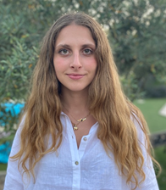

Amandine Senequier 01392 724752 A.Senequier@exeter.ac.uk

Thank you
Thank you for taking the time to read this information sheet.
We would also like to thank the young people with cystic fibrosis and their parents/carers were involved in reviewing this information sheet.

Please keep this information sheet for future reference.

