Digi PA for Youth CF – Feasibility
Children’s Health and Exercise Research Centre, Sport and Health Sciences, College of Life and Environmental Sciences, St Luke’s Campus, University of Exeter, Exeter, UK, EX1 2LU.

Principal Investigator: Dr Samantha van Beurden
Telephone: 01392 726440
Email: s.b.vanbeurden@exeter.ac.uk

Information Sheet for Parents and Carers

Study title
Feasibility randomised controlled trial of digital physical activity promotion materials for young people with cystic fibrosis (Digi PA for Youth CF – Feasibility).

Invitation and summary
Thank you for taking the time to read this information sheet. We are seeking young people (12-18 years old) who have been diagnosed with cystic fibrosis and can access the internet, via any device (e.g., smart phone), to take part in this study. You are receiving this because a young person (12-15 years old) with cystic fibrosis in your care has either: (1) been deemed to be eligible and potentially interested in this study, or (2) already expressed interest in taking part, having responded to a study advert. In the case of the former, the study eligibility check was made by a member of staff at the paediatric cystic fibrosis clinic or a research nurse from the clinic’s NHS Trust.
The research team would like to see whether the digital delivery of physical activity promotion material is deemed acceptable, useable, and engaging by young people with cystic fibrosis. In the future, we would like to conduct a bigger study where we would like to see whether the material designed for this study is better – resulting in better ‘quality of life’ – than another type of digital physical activity promotion material. Therefore, this current study is also interested in finding out if doing a bigger study is feasible.
Taking part in the study is completely up to you and the young person in your care. Before deciding, we would like you to understand why this study is being done and what it will involve. So, please take your time to read the following information. We suggest that this should take approximately 10 minutes. You can talk about this information with other people and/or The Researcher to better inform your decision about whether to take part.

Why are we doing this study?
Being more physically active has important health benefits for everyone. As a result, achieving recommended weekly physical activity levels is encouraged within the UK. People with cystic fibrosis can obtain extra benefits, including improved lung function and sputum clearance, as well as many psychological and social benefits.
First, we would like to see whether digitally delivering physical activity promotion is accessible, usable, and engaging in supporting young people with cystic fibrosis to be more physically active. Secondly, we would like to find out whether the things we would like to do in a bigger study are even possible and acceptable to potential participants. For example, with the current study we would like to check if it is possible to recruit enough participants over an acceptable period, and if people are able and willing to: (a) complete the various questionnaires, (b) take part in interviews, and (c) wear activity monitors at different time points in the study period.

What would taking part involve?
If the young person with cystic fibrosis in your care is interested in taking part in this study, we would like to discuss this with you via a telephone call (or teleconferencing software). This initial conversation will mainly give you an opportunity to ask any questions that you may have but will also be used to describe what this study is about, and what it involves. You can either contact the researcher directly via telephone, or you could send an email with your preferred contact time and method (e.g., telephone or teleconferencing software). If you both feel happy to take part, we will ask you (parent/carer) to sign a consent form, alongside an assent form (completed by participant).
Having completed and returned the consent/assent forms, we will need to use information provided by the young person with cystic fibrosis in your care for this study. This information will involve them completing several questionnaires, wearing an activity monitor, being randomly selected to have access to one of two types of digital physical activity promotion material, and may also involve being asked to take part in interviews (via telephone or teleconferencing software). People will use this information to do the research or to check these records to make sure that the research is being done properly. Also, people who do not need to know who the young person with cystic fibrosis in your care is will not be able to see their name or contact details.
Participation in the study will last for a total of six months (24 weeks), whereby the described tasks will need to be completed at the start of the study (baseline), then one month into the study, and again at the end of the 6-month study period. Usual clinical care will not be affected by taking part in this study. Details of the specific study tasks are included in the figure on page 3 of this information sheet.
During the 6-month study period, you and the young person with cystic fibrosis in your care will be required not to share details of the digital physical activity promotion material received with other people. This is to make sure that the results are as useful as possible.
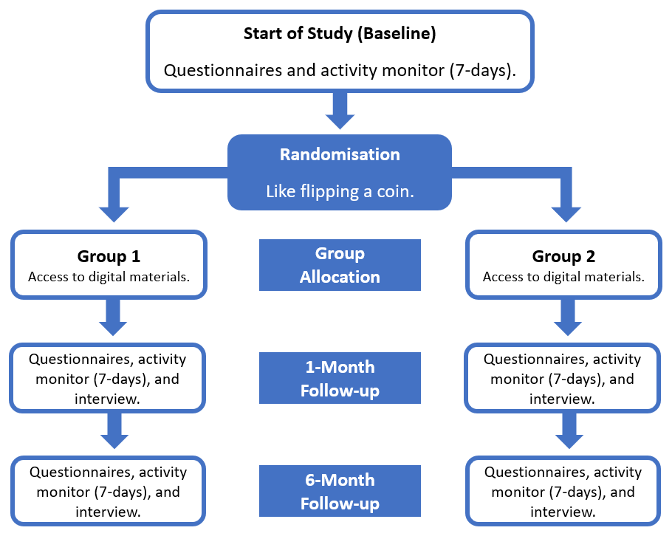

What are the possible benefits of taking part?
We cannot guarantee that the young person with cystic fibrosis in your care will receive any benefits from taking part in this study. However, being physically active has the potential to improve the physical and mental health and wellbeing of people with cystic fibrosis. As a result, having access to digital physical activity promotion material may well help them improve their knowledge about how to best integrate physical activity into their daily life. Being involved with this study also provides them with an opportunity to contribute to the development of digital physical activity promotion material – which may help to improve future patient care.
As a thank you for taking part, the participant will receive a £10 gift voucher upon completion of the tasks at each data collection time-point (baseline, 1-month, and 6-months). This means that they can receive up to £30 in gift vouchers over the course of the study.

What are the possible disadvantages and risks of taking part?
This is a low-risk study that will not involve invasive treatment and/or procedures. The main disadvantage is the amount of time that will be spent taking part in the study. However, over the 6-month study period, the different research tasks are likely to take a few hours to complete at each data collection time-point (questionnaires and interviews). That said, their use of the digital physical activity promotion materials might take longer (please note that this is entirely up to the participant). As it is digital, they can access it whenever they want, via any device with access to the internet, during the 6-month study period. However, please note that access to the digital physical activity resources will be stopped once the study has ended.
All one-to-one interviews will be held at a time that suits the young person with cystic fibrosis in your care and will be via telephone or videoconferencing software (e.g., Zoom). To ensure that these interviews are kept confidential (if using videoconferencing software) we will make use of the ‘waiting room’ function to screen the identity of the person logging in. This way no-one else can enter.
A few risks and disadvantages related to physical activity and how we measure it need to be outlined. Increased physical activity levels can lead to breathlessness and might increase the risk of injury. If breathlessness occurs, although this is normal for physical activity, it can be upsetting to those with cystic fibrosis. Should you have any concern about breathlessness and being physically active, please contact the young person’s CF care team. As part of our study procedures, we will also ask for your permission to inform the young person’s CF care team and GP about their study participation – and will request for them to notify us should there be any reason participation should be halted. If either the young person’s CF care team or GP do notify us that there is a reason that they should not be taking part, we will contact you and halt any further participation. Please note that we will not be informed of the reason by the young person’s CF care team and/or GP.
If injury does occur while participating in this study, please notify us immediately with the time and nature of the injury and seek medical assistance, if necessary.
A disadvantage in this study may also come from wearing an activity monitor. For some, this may be a little bit uncomfortable (like wearing a regular wristwatch). If wearing it becomes too uncomfortable, please know that they can take it off. It is also important to point out that the activity monitor may have been worn by more than one person with CF. To reduce the risk of cross-infection, the researcher will be adhering to infection control practices.
As a last point, it is important to highlight that participation in this study will not affect standard clinical care – they will continue all their treatments as usual (e.g., therapies and medications), as directed by their care team. As mentioned above, we just ask for your permission to notify them of study participation. Related to the assessment and management of risk, please note that procedures are in place to manage Adverse Events and/or other complaints.

Does the young person with cystic fibrosis in your care have to take part?
Please remember that participation in this study is entirely voluntary. It is up to you and the young person with cystic fibrosis in your care to decide whether to take part. If you decide that they can participate in this study, you will be asked to sign a consent form before the start of the study, in addition to an assent form (to be completed by the participating young person). You will be given a copy of these forms and we will also ask you to keep this information sheet for your records as it contains key information about the study and various contact details.
Should the participant wish to withdraw from the study, this can be done at any time, without having to give a reason, but we will keep information about them that we already have. If requested, we can remove all their data from our records. However, please note that this request is time-limited since we will need to fully anonymise the dataset at the end of the study and, therefore, will not be able to identify which data relates to which participant. Also, as we need to manage participant records in specific ways for the research to be reliable, we won’t be able to let you see or change the data we hold about the young person with cystic fibrosis in your care.

Will the data collected remain confidential?
Throughout the study, all electronic data files will be encrypted and password-protected via the University of Exeter's Secure Data Research Hub. As the study sponsor, the Royal Devon University Healthcare NHS Foundation Trust is acting as the Data Controller. Only relevant members of the Digi PA for Youth CF Trial Management Group will have access to the Secure Data Research Hub, via their IT accounts. This includes individuals from the University of Exeter, University of Bristol, and Royal Devon University Healthcare NHS Foundation Trust. If necessary, this data may also be accessed by relevant regulatory authorities. All data collected will be kept confidential and in accordance with General Data Protection Regulation. All data files will be stored anonymously using unique participant numbers. All personally identifiable information (e.g., contact details) will be stored separately and securely. None of this information will be shared outside of the Trial Management Group. Any paper-based data generated throughout this study will be typed up electronically at The Researcher’s earliest convenience and the paper copy will then be destroyed. Any contact details will be destroyed following the study (held for up to 3-months) unless you have provided consent for us to approach you for future related projects.
The interviews we conduct will be audio-recorded. The audio-recordings will be transcribed by an external company (confidentiality agreement in place) and any identifiable information (e.g., person or place names) will be redacted. The recordings will be deleted after transcripts have been checked for accuracy by the researcher. The transcripts will be anonymised using unique participant numbers. Any interview notes taken by the researcher during interviews will be typed up and stored electronically and the paper copy will be securely destroyed.
The only time we may need to break confidentiality would be if the participant discloses some information that might make the researcher think that they may be at risk of being hurt, or that they are not safe where they are. At this point, we would need to let relevant authorities know to safeguard their interests. Confidentiality will only be broken for the safety of a child’s welfare.

What happens to the data at the end of the study?
At the end of the study all data will be fully anonymised (i.e., no-one will be able to work out that the young person with cystic fibrosis in your care took part in this study), meaning that the electronic document linking the participant’s identity to their unique participant number will be deleted. In support of ‘open science,’ an anonymised copy of this study data may be made publicly accessible for an indefinite period, for example via the Open Science Framework (osf.io). This means that if other people, such as researchers not part of this team, have interesting questions and the data from this study is suitable to answer that question – they can request to use this data for that. This means there will be less burden on the target population to take part in more studies to gather data that is already in existence.

What will happen to the results of this study?
If you and the participant have provided consent/assent to be sent a summary of the results, we will send you a study report that will include the key findings. We will also publish the results in scientific journals and to present them at conferences in the UK and abroad. We may wish to use quotes (data) from the interviews to illustrate our findings, this may be used in reports, articles, websites, training materials, and/or the digital intervention itself. Please note that the data presented will always remain anonymous and no real names will appear in any results. An anonymised copy of the study data may also be made publicly accessible, for example via the Open Science Framework (osf.io). This anonymised data will be publicly accessible for an indefinite period. The data may then be used for re-analysis/secondary analyses by the same and/or other researchers – without obtaining further consent. The scope of any secondary analyses is currently unknown.

Who has reviewed this study?
All research taking place in the NHS is assessed by an independent group of people – known as a Research Ethics Committee – who safeguard the rights, safety, dignity, and wellbeing of people participating in NHS-approved research. When reviewing a research study application, a Research Ethics Committee will provide their opinion about whether the research is ethical. On behalf of the Health Research Authority and NHS, this study has both been reviewed and approved by a Research Ethics Committee (West Midlands - Solihull) based in the UK (reference: 22/WM/0156, approval date 15/09/2022).

Who is funding and sponsoring this study?
The National Institute for Health Research is funding this study via their “Research for Patient Benefit” programme. Research funded via this programme aims to increase the effectiveness of NHS services, provide value for money, and be of direct benefit to patients. The funder has had no role in the overall design of the study and will play no role in the conduct, write-up, and dissemination of the research.
The Royal Devon University Healthcare NHS Foundation Trust is sponsoring this study. This study has been reviewed and approved by all applicable regulatory bodies.
While not funding or sponsoring this study, it is important to highlight that the Cystic Fibrosis Trust’s Research Scientific Oversight Board have reviewed relevant study information. Based on their review, this study has been awarded “Clinical Trials Accelerator Platform badging status” and will be advertised on their “Trials Tracker” website.

What if there is a problem?
If you have any concerns and/or complaints relating to taking part in this study, please contact the Principal Investigator – Dr Samantha van Beurden (S.B.Vanbeurden@exeter.ac.uk).
If you believe that you have been harmed in any way by taking part in this study, you have the right to pursue a complaint and seek any resulting compensation through the Royal Devon University Healthcare NHS Foundation Trust who are acting as the research sponsor. Details about this are available from the research team. Also, as a patient of the NHS, you have the right to pursue a complaint through the usual NHS process. To do so, you can submit a written complaint to the Patient Liaison Manager, Complaints Office, Royal Devon University Healthcare NHS Foundation Trust, Barrack Road, Exeter, EX2 5DW, 01392 402093. Note that the NHS has no legal liability for non-negligent harm. However, if you are harmed and this is due to someone’s negligence, you may have grounds for a legal action against the Royal Devon University Healthcare NHS Foundation Trust, but you may have to pay your legal costs.

Where can you find out more about how the data is used?
You can find out more about how the data is used:
- at the following website: https://www.hra.nhs.uk/information-about-patients/.
- by asking one of the research team.
- by sending an email to The Researcher (details on p.8).
The Royal Devon University Healthcare NHS Foundation Trust’s Data Protection Officer can be contacted by sending an email to: rde-tr.dataprotectionofficer@nhs.net. To contact the University of Exeter’s Data Protection Officer, please use the following email address: dataprotection@exeter.ac.uk.

Contact details for further information:
If you have any questions about this study, or would like more information, please contact Amandine Senequier and/or Dr Samantha van Beurden, as detailed below:
The Researcher, University of Exeter:
Amandine Senequier
Address: Children’s Health and Exercise Research Centre, Sport and Health Sciences, College of Life and Environmental Sciences, University of Exeter, St Luke’s Campus, Heavitree Road, Exeter, Devon, EX1 2LU, UK.
Tel: 01392 724752. Email: A.Senequier@exeter.ac.uk
Principal Investigator, University of Exeter:  Dr Samantha van Beurden  Address: Primary Care Research Group, Smeall Building, University of Exeter Medical School, College of Medicine and Health, St Luke’s Campus, Heavitree Road, Exeter, Devon, EX1 2LU, UK.  Tel: 01392 726440. Email: s.b.vanbeurden@exeter.ac.uk | 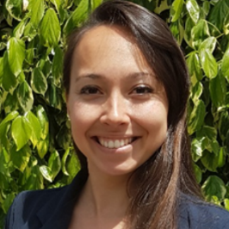

Thank you
Thank you for taking the time to read this information sheet.
We would also like to thank the young people with cystic fibrosis and their parents/carers were involved in reviewing this information sheet.

Please retain this information sheet for future reference.

